President’s Corner:
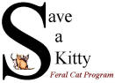
SAVE A KITTY FERAL CAT PROGRAM, INC.

Publisher SAK Volunteers Volume No. 18 Issue No. 2 Date 2nd Qtr. 2021
Parkersburg, WV NEWSLETTER www.saveakitty.org

I will continue to feature “working cats” in future editions of the newsletter but this time I want to thank the Board of Directors and our many volunteers who work continually to help community cats and kittens. I also want to thank the many caring and compassionate residents who feed, shelter and care for these less fortunate felines. Providing sterilization and vaccines at no cost to the caretakers is our mission. Spay/neuter and vaccinations help these cats to thrive. The cats are healthier and intact mating behaviors are eliminated.
Our Board of Directors:
President/Founder-Kandi Habeb
Vice-President-Barbara Buskirk
Secretary-Pamela Kidder
Medical Coordinator-Vickie Yencha
Volunteer Coordinator-Alice Rolette
TNR Coordinator-Carol Hanna

Upcoming Events
July 1, 2021-2nd annual 300 club begins.

July 17, 2021-Designer Purse Bingo-Moose Lodge. 20 games for $20. Raffles, 50/50, early bird tickets and much more. Concessions and baked goods. Get your tickets at Buttermore Jewelers, Bullseye Antiques or Mulberry Lane Country Store. Remaining tickets will be available at the door. Doors open at 1 pm and games begin at 2 pm.

September 11, 2021-Rascal Mobile Surgery Unit
Rascal Mobile Surgery Unit
On May 22nd, the Rascal Mobile Surgery Unit held a clinic for Save a Kitty. We were able to sterilize 40 cats and kittens. A total of 21 spays and 19 neuters were completed in one day. Amazing impact on cat over-population! Special thanks to the mobile unit and all of our amazing volunteers who worked all day. We appreciate all of you!
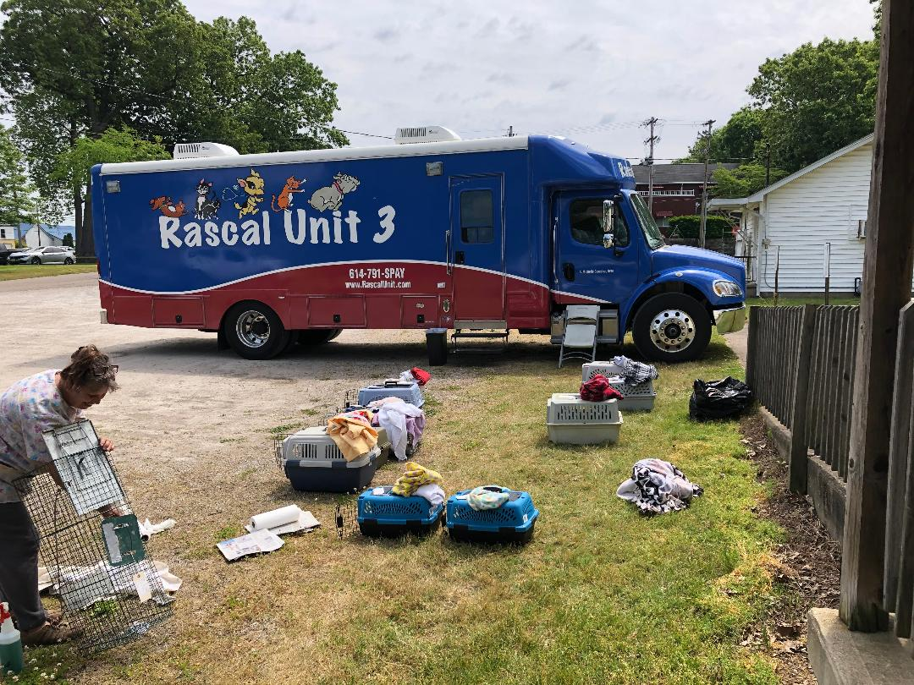
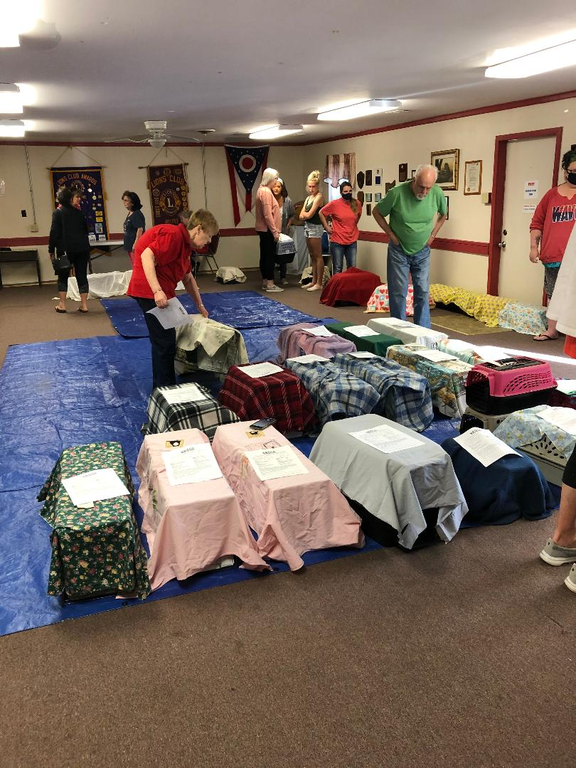
Williamstown, WV community cats
If you are a current resident of Williamstown, WV and are feeding/caretaking stray or feral cats, we can help with spay/neuter and vaccines. Please contact our program at our main number, 304.480.9242 or visit our website to fill out the three required forms. www.saveakitty.org under the “forms” tab.

Progress!
As of June 30, 2021, our TNR program has provided 116 spay/neuter surgeries and vaccinations to community cats at no cost to the caretaker. Since our inception in June 2004, we have provided 7,971 sterilizations to residents who are caring for the cats/kittens. Your kind donations have made this possible. Sterilizing almost 8,000 free-roaming cats has made a huge impact on the number of cats in the community and decreased the intake/euthanasia of cats/kittens at our local shelter. It is the solution for humane, cat population control. The pandemic has definitely slowed the availability of spay/neuter for our program this year, but we continue to find ways to help as many cats as we can.

Congratulations to our 300 club raffle winners so far!
$100 winners were:
Week 1-Kristy Oldaker-donated to SAK
Week 2-Rodney Shawver
Week 3-Angie Lynch
Week 4-Lyle Parkins-donated to SAK
Week 5-Betty Naab
Week 6-Tamara & Chuck Lewis-donated to SAK
Week 7-Tonya Bertagnolli-donated to SAK
Week 8-Gary McIntyre-donated to SAK
Week 9-Amber Johnson
Week 10-Debra Cottle-donated to SAK
Week 11-Roger Pettit-donated to SAK
Week 12-Shari Metz-donated to SAK
Week 13-Theresa Parkins
Week 14-Luke Zyla-donated to SAK
Week 15-Marcela Meneses
Week 16-Debbie Hines-donated to SAK
Week 17-Kim Hornbeck-donated to SAK
Week 18-Jackie Lindamood
Week 19-DeeAnn Baker-donated to SAK
Week 20-Bobbie Jones
Week 21-Tamara & Chuck Lewis-donated to SAK
Week 22-Kristy Oldaker-donated to SAK
Week 23-Debbie Cline
Week 24-Patsy Hupp
Week 25-Ed Bays
Week 26-Carol Butler ($500 winner)
Week 27-Dave Buck
Week 28-Kim McCoy-donated to SAK
Week 29-Bryan Stone
Week 30-Kennedy Kidder-donated to SAK
Week 31-Tony Buck
Week 32-Elbert & Victoria Cline
Week 33-Tim Glover
Week 34-Bobbie Pitsenberger-donated to SAK
Week 35-Judith Kemp
Week 36-Bryan Stone-donated to SAK
Week 37-Amber Johnson
Week 38-Joan Smith-donated to SAK
Week 39-Carol Kieffer-donated to SAK
Week 40-Theresa Parkins
There are 11 more drawings for $100 winners and our final drawing (week 52) for $1,000. We appreciate our supporters purchasing 300 club tickets and want to thank the generous winners who donated back to Save a Kitty. Our 2nd annual 300 club raffle will begin July 1, 2021. If you are interested in purchasing a 300-club ticket, please call 304.480.9242 or see our Facebook page for more information. We are listed as Save a Kitty Feral Cat Program.
